Http Communication
Http Methods
PUT and PATCH Difference
Http protocols
HTTP VS HTTPS
Spring Authentication And Authorization using Jwt Security

Hypertext Transfer Protocol (HTTP) Communication
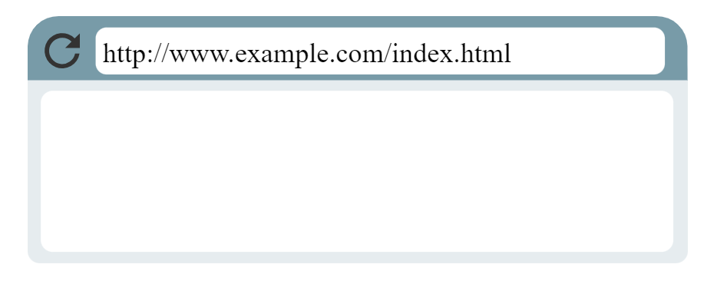
Whenever the user visit a web browser type URL (http://www.example.com/index.html), it uses the Hypertext Transfer Protocol (HTTP) to download that page from another computer somewhere on the Internet.

Step 1: Direct browser to URL
URL: it starts with "http". That's a signal to the browser that it needs to use HTTP to fetch the document for that URL.

Step 2: Browser looks up IP
When we type "wikipedia.org" (Domain Name) Those domain names map to IP addresses, the true location of the domain's computers.
The browser uses a DNS resolver to map the domain to an IP address:
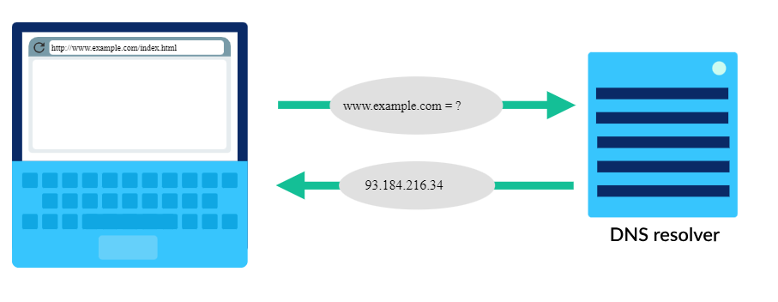

Step 3: Browser sends HTTP request
Once the browser identifies the IP address of the computer hosting the requested URL, it sends an HTTP request as follows.

HTTP request messages
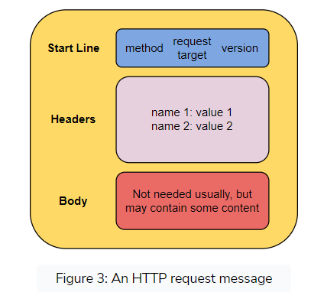

It's divided into three fields: start line, headers, and body.
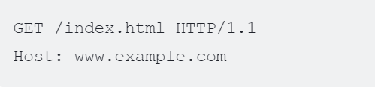

First part of request is start line
The start line first one is HTTP Methods
- Get requests a specific resource in its in its entirely
- POST adds content, messages, or data to a new page under an existing web resource
- PUT directly modifies an existing web resource or creates a new URI if need be
- DELETE gets rid of a specified resource
- PATCH partially modifies a web resource
Second one is request is target i.e, "/index.html". The host computer stores the content of the entire website, so the browser needs to be specific about which page to load. The final part contains version of the protocol: "HTTP/1.1".
GET /api/data HTTP/1.1 :-In the below example we can see GET method is used to send a request to the /api/data endpoint on the example.com server using HTTP/1.1 protocol.
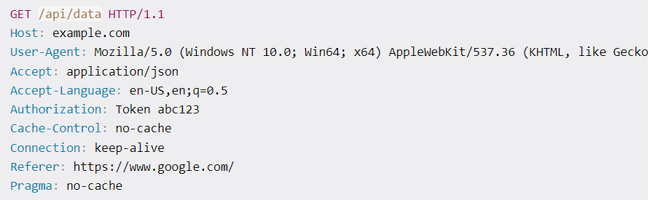
Second part of request is headers that hold the value in key pairs

Host: example.com
(This header specifies the host name of the server that the client is trying to connect to.)
User-Agent: Mozilla/5.0 (Windows NT 10.0; Win64; x64) AppleWebKit/537.36 (KHTML, like Gecko) Chrome/89.0.4389.82 Safari/537.36

(This header provides information about the client that is making the request (in this case, a version of the Mozilla browser).

Accept: application/json

(This header specifies the MIME types of data that the client is willing to accept in the response.)

Accept-Language: en-US,en;q=0.5

(This header specifies the preferred language(s) for the response.)

Authorization: Token abc123
(This header provides an access token (in this case, Token abc123) for authentication purposes.)

Cache-Control: no-cache
(This header specifies caching directives for both requests and responses. )

Connection: keep-alive
(This header specifies options for the connection handling between client and server)

Referer: https://www.google.com/
(This header specifies the URL of the page that linked to current page.)

Content type:- This header specifies the MIME type of the data that is being sent in the body of the request, but it is not used in this example because this is a GET request without a request body.

Third part of request is Body in case of Get and Delete HTTP methods the body is empty and in case of Post, Patch and PUT contains the body which need to update

If the request contains Post HTTP requst then the request includes these headers:
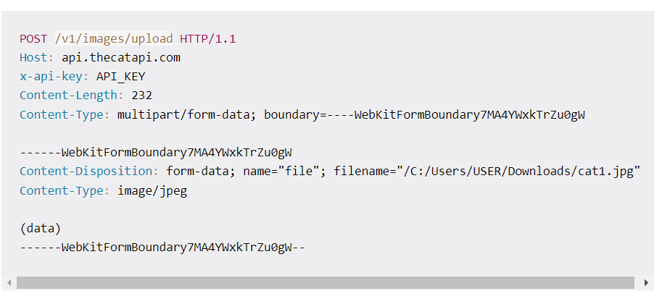
Host: This header specifies the host name of the server that the client is trying to connect to.
Content-Type: The request is uploading an image file named cat1.jpg using a type of data called multipart/form-data. The image is in JPEG format and its content is included in the request body.
x-api-key: This header provides an API key for authentication purposes.
Content-Length: This header specifies the length of the request body in bytes. The value of this field is 232.
When the server receives this request, it will parse the request body and use it to create a new entry in the Cat API database. The server will then return a response that includes information about the new entry, such as the image URL and the database ID.

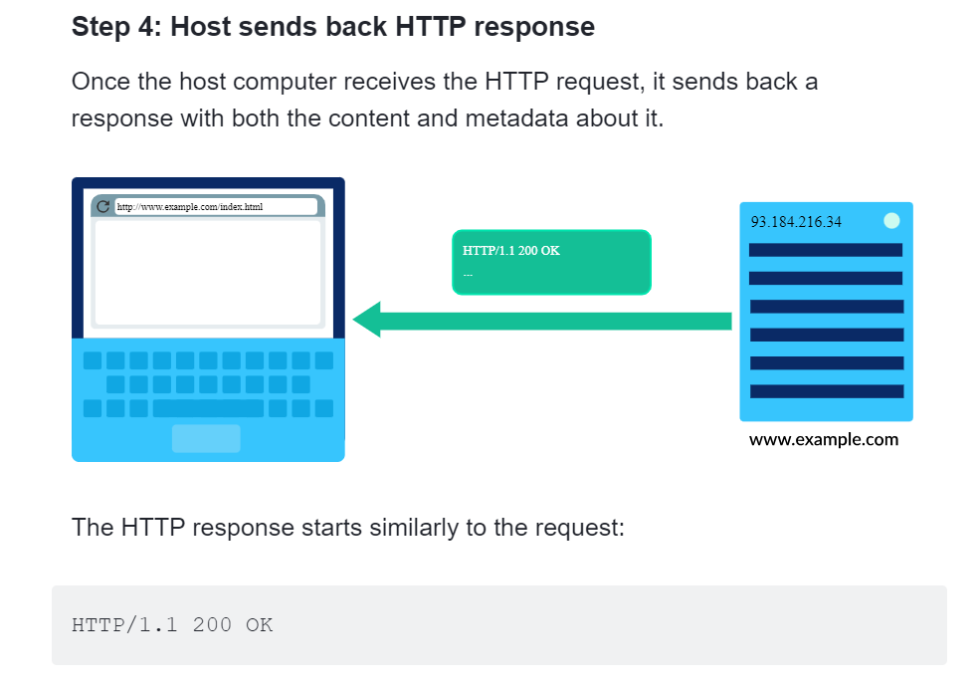

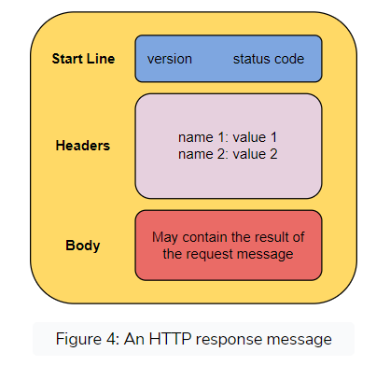

The response begins with the protocol and followed by version, "HTTP/1.1".
HTTP Version:- It has the same purpose as described for HTTP request messages.
The next number is HTTP status code, and in this case, it's 200. That code represents a successful retrieval of the document ("OK").

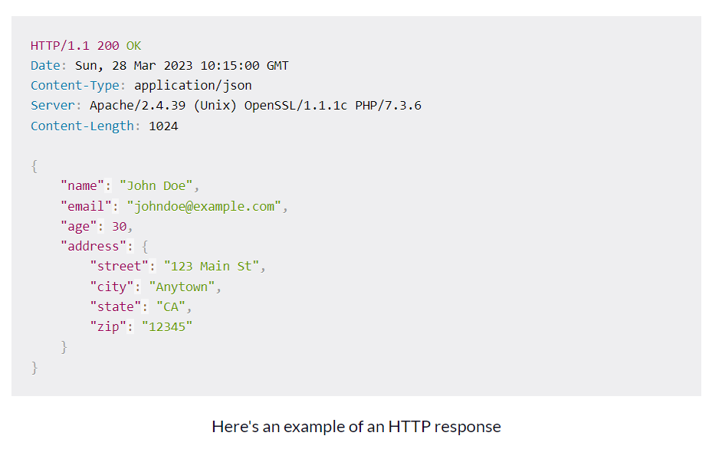

The status line contains the HTTP version, a status code indicating the outcome of the request, and a corresponding message.
The headers provide additional information about the response, such as the content type of the message body or the date and time that the response was sent.
The message body contains the actual response data, such as HTML, JSON, or XML content.
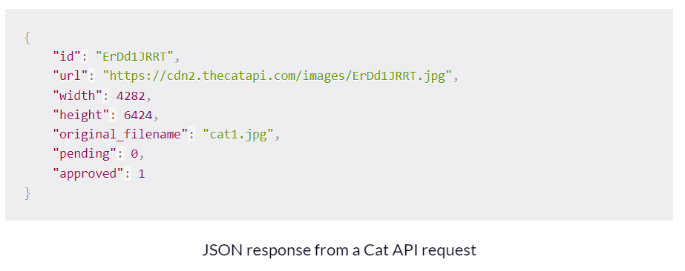
If the server failed to retrieve the document, the status codes provide more information, like if the failure was due to client error or server error. For example, the most well known status code is 404 ("Page not found"). That happens whenever you visit a path on a server that doesn't correspond to any document. Since users have a habit of typing URLs incorrectly
The status code indicates the success/failure of the request sent in the HTTP request message. Multiple status codes can be divided into the following groups,
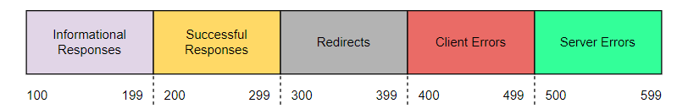

- 200 OK. This means that the request, such as GET or POST, worked and is being acted upon.
- 300 Moved Permanently. This response code means that the URL of the requested resource has been changed permanently.
- 401 Unauthorized. The client, or user making the request of the server, has not been authenticated.
- 403 Forbidden. The client's identity is known but has not been given access authorization.
- 404 Not Found. This is the most frequent error code. It means that the URL is not recognized or the resource at the location does not exist.
- 500 Internal Server Error. The server has encountered a situation it doesn't know how to handle.
The next part of an HTTP response are the headers. They give the browser additional details and help the browser to render the content.
These two headers are common to most requests
Content-Type: text/html; charset=UTF-8
Content-Length: 208

The content-type tells the browser what type of document it's sending back. A common type on the web is "text/html", as all web pages are HTML text files. Other types are possible, like images ("image/png"), videos ("video/mpeg"), script ("application/javascript").The content-length gives the length of the document in bytes,
The response message body contains the resource requested in the request message. For example, a response message sent to a GET request message will have the requested resource in the message's body.
Finally, the HTTP response writes out the actual document requested. This page is a simple HTML file:
<!DOCTYPE html>
<html>
<head>
<title>Example Domain</title>
</head>
<body>
<h1>Example Domain</h1>
<p>This domain is to be used for illustrative examples in documents.</p>
</body>
</html>

Step 5: The browser renders the response
The browser now has all the information it needs to render the document requested.
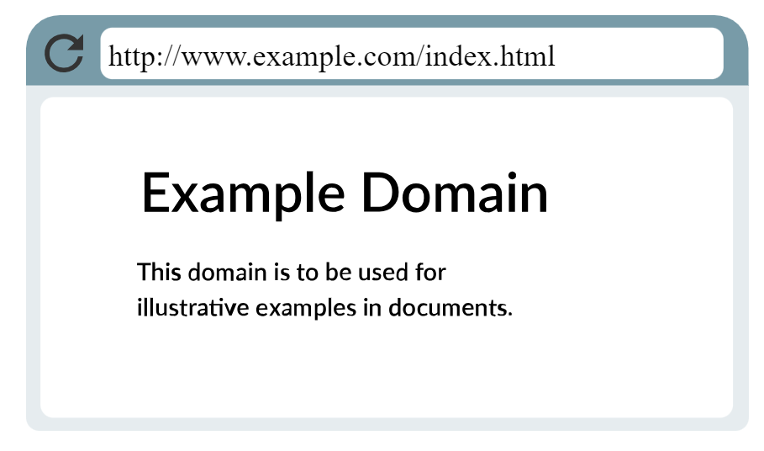
debugging tools that let you view HTTP requests and their responses as you browse the web.

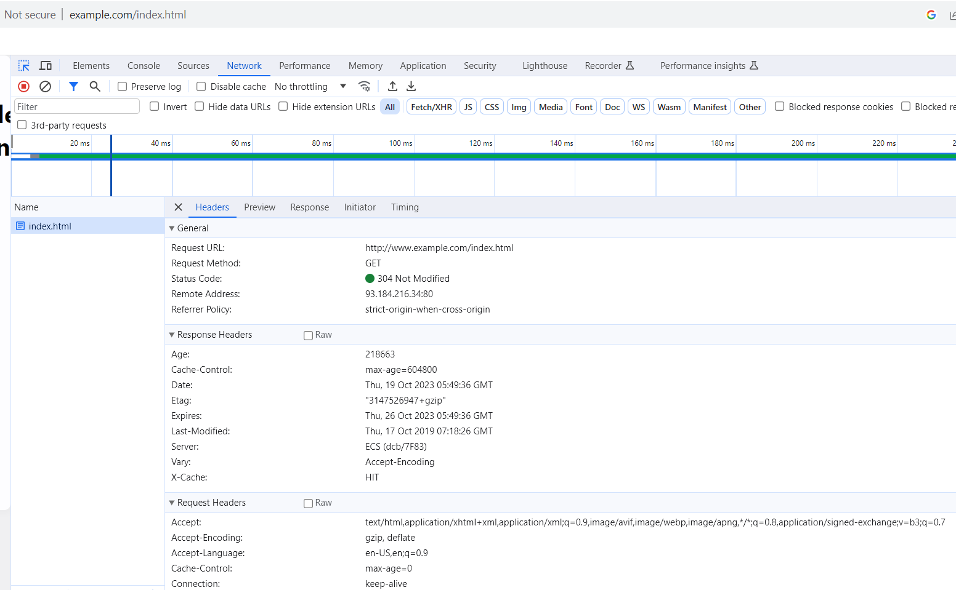

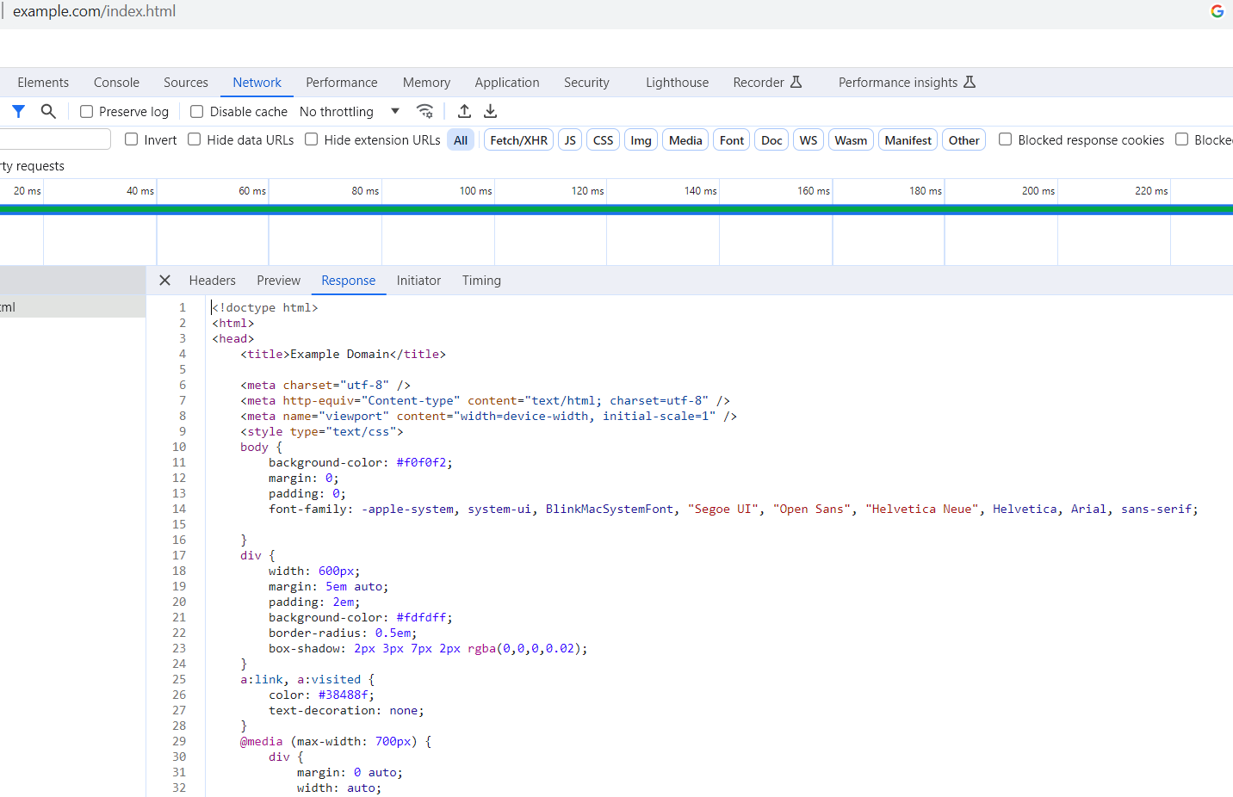

Put vs Patch

The following table captures the main differences between PUT and PATCH:
 | PUT | PATCH
Usage | Updates all the fields of a resource. Replaces the entire resource with the new data provided. | Partially updates a resource. Applies changes to specific fields.
Required fields | Requires sending the entire updated resource. | Allows sending only changes or updates.
Response | The complete updated resource. | The complete updated resource.

Persistent vs non-persistent HTTP
In non-persistent HTTP, the client opens a TCP connection to the server, sends at most one object over the connection using the request/response, and then closes the connection. Thereby, downloading multiple objects requires multiple connections.
In persistent HTTP, the client opens a TCP connection to the server. Multiple objects can then be transferred over this connection if needed through individual request/response cycles, and then the connection closes the connection.

Difference between HTTP and HTTPS
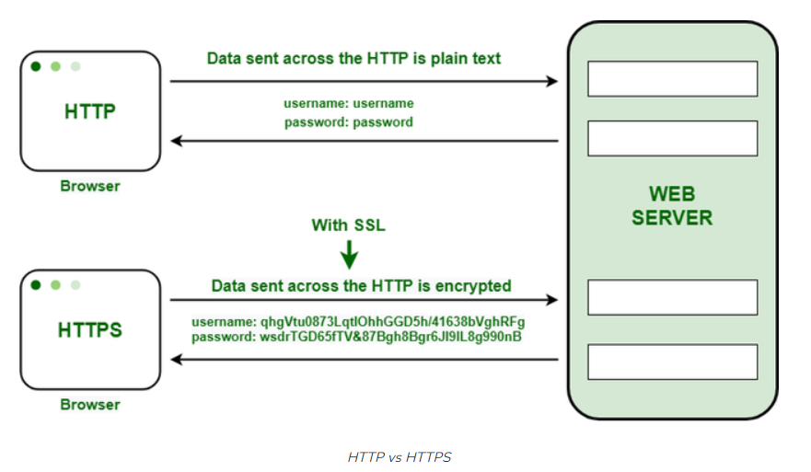

HTTP (HyperText Transfer Protocol.) | HTTPS (HTTPS stands for HyperText Transfer Protocol Secure)
URL begins with “http://”. And uses port number 80 for communication. | URL starts with “https://”.And uses port number 443 for communication.
It is unsecured as the plain text is sent, which can be accessible by the hackers. | It is secure as it sends the encrypted data which hackers cannot understand.
It does not use SSL. it is Insecure. | It uses SSL that provides the encryption of the data.
HTTP Works at the Application Layer. | HTTPS works at Transport Layer.
HTTP does not use encryption, which results in low security in comparison to HTTPS. | HTTPS uses Encryption which results in better security than HTTP.
HTTP speed is faster than HTTPS. | HTTPS speed is slower than HTTP.
HTTP does not use data hashtags to secure data. | HTTPS will have the data before sending it and returning it to its original state on the receiver side.
HTTP is used to transfer text, video, images and blog writing via web pages. | HTTPS is used to transfer data securely via a network. that require to transmit the bank account details or credit card numbers.

SSL certificates
To enable HTTPS on a website, it must have a valid SSL (secure sockets layer) certificate. This certificate is used to encrypt information as it is being sent between your computer and the server. An SSL certificate contains a public key and a private key. The public key encrypts information, while the private key decrypts it.
When you visit a website, your browser checks to see if the site’s SSL Certificate is valid. You will see a green padlock in the address bar if it is. If it is not, you will see a warning message.

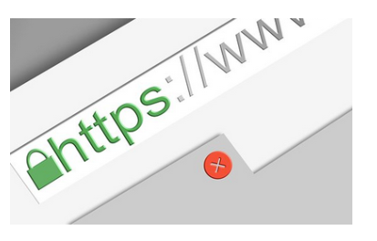

TLS certificates
Transport Layer Security (TLS) is similarly a security protocol that is used to encrypt information as it is being sent over the Internet. TLS is an improved version of the security protocol to replace SSL, which has been deprecated. TLS uses more robust encryption algorithms and provides better security than SSL., although the two terms are often used inter
changeably.

How Spring security work Internally
In case of spring security request will not go directly to the server because that request not yet authenticated at this time spring security frame work uses a filter between the request and response. First request will go to the filter. if my request got authenticated successfully then request will go to the server. If authentication get failed then will get 401 unauthorized error

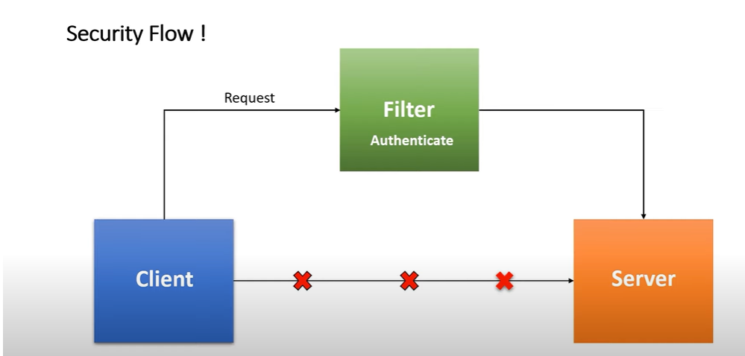

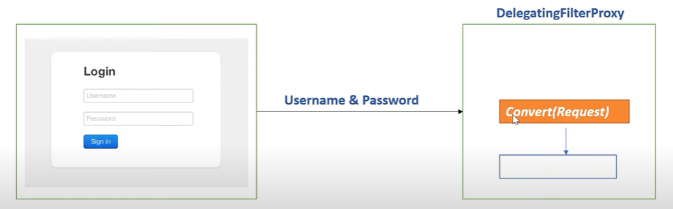

when the user gets login the first request will got to filter i.e, Delegating filter proxy which given by spring security. The filter first extract servlet request convert in to Authentication object. The Authentication object contains username and password as a principle object

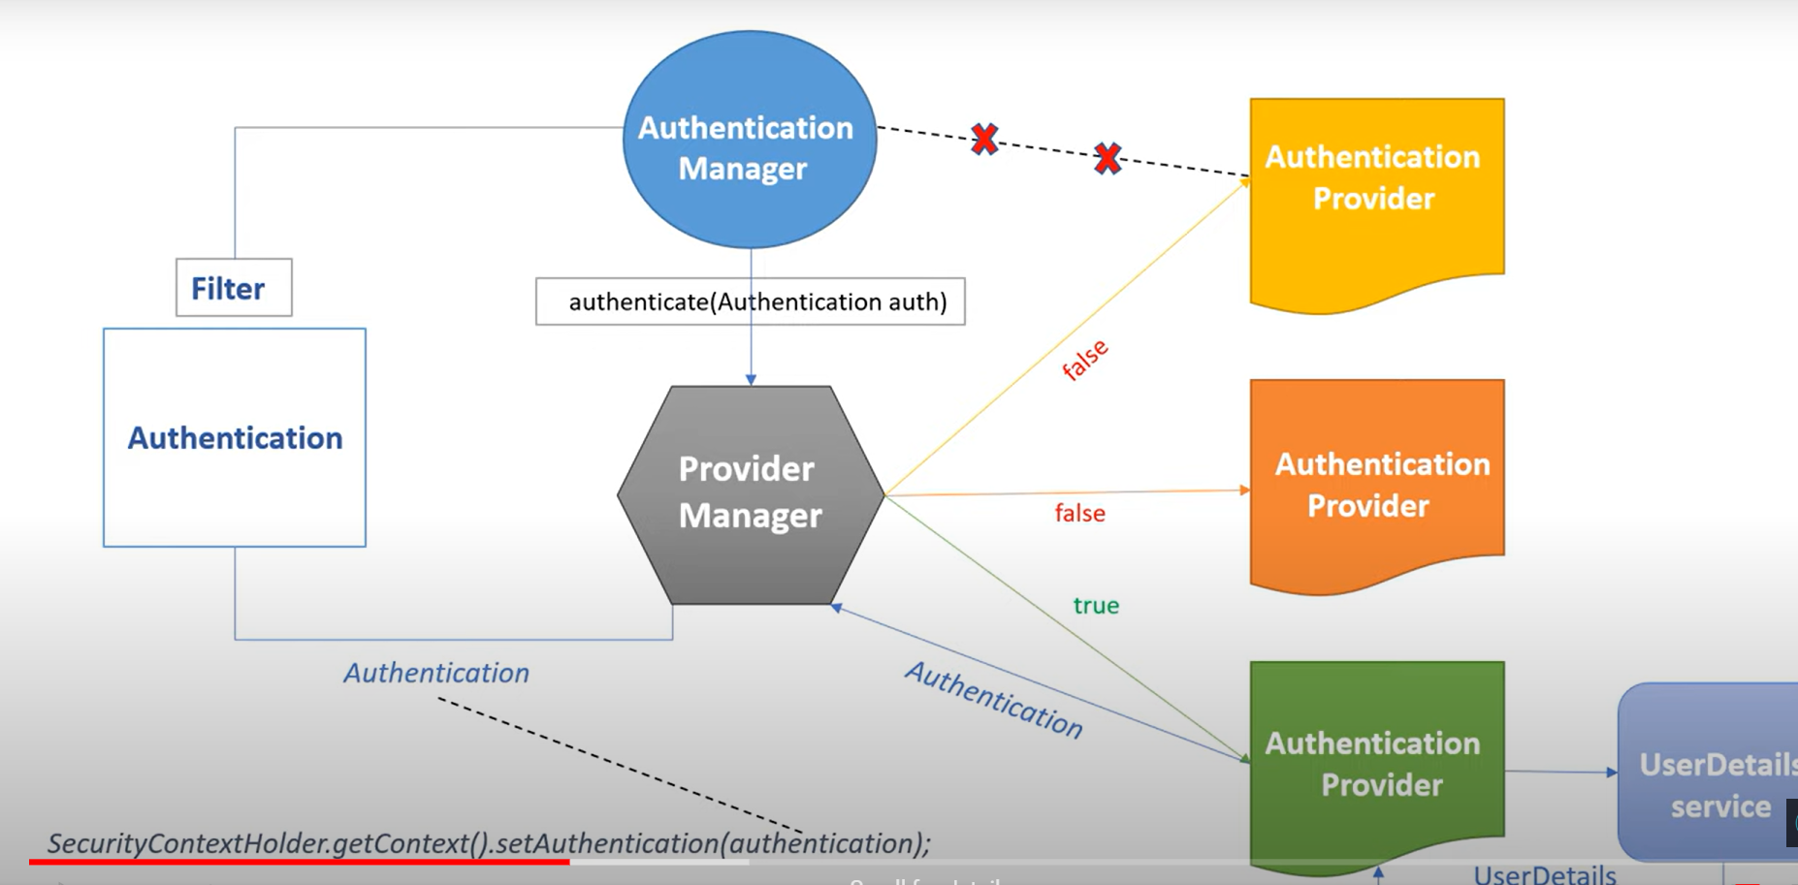
The filter delegate request to Authentication Manager and will take authentication object as an argument to authentication manager it will call authenticate method.
Authentication manger delegate that request to Provider Manager and provider manager have several implementation methods of Authentication provider like How to authenticate using token, based on username and password, LDAP sever etc...
provider manager will look for appropriate authentication provider by checking the support() method from the Authentication provider if he get correct authentication provider then delegate that request to user detail service provide by spring security frame work from the user details service it directly hit database. If user exists in database authentication provider will authenticate it and return valid authentication object to provider manager. Now provider manager return same authentication object to filter and filter set authentication object to security context
Once the authentication object set to your security context then request will redirect to server.

Spring security using JWT Authentication and Authorization
This is the secure way to communicate between client and server advantage using of this Json web token is follows completely stateless authentication mechanism it means all the user input and user state never saved in server memory or cockies
user input i.e, user name and password in encrypted format and Json web token consist three parts which is separated by dot(.)

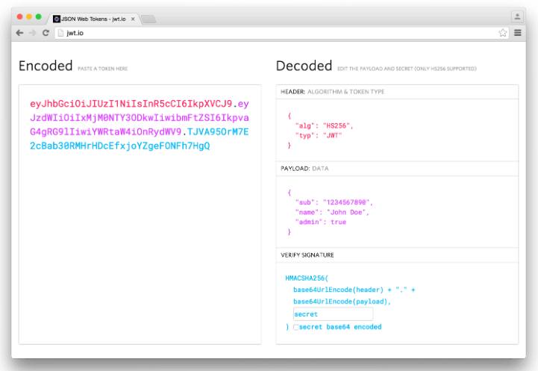

First part is header contains the which type of token we are using i.e, JWT and which type of algorithm we are using like “HS256”, “HS384”, “HS512”, “PS512”, etc…..
Second part is Payload which contains name of the login user, when this JWT toke got created and what will be the expiration time of the token
Third part is Verify Signature contains the above two parts of the Header and payload will convert that in to base64Url encoder
with above these three we can build valid JWT token which we can further used for authorization
major cycle,minor cycle ogf gc

